- How to create directory?
- How to go inside Practice directory?
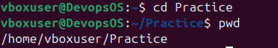
- How to create file with zero size?
- How to check file is create with zero size?
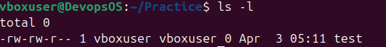
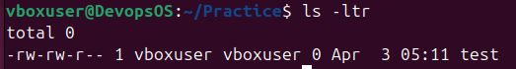
- How to check directory all file(Hidden + unhidden file)
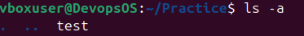
- What is difference between ls-a and ll command?
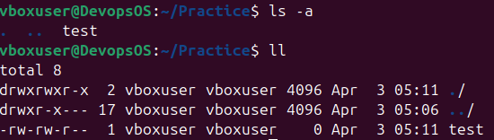
If You see above screen shot in ls -a command only gives you file name and directory name.
If you see above screen shot in ll command gives you file and directory name with all details.
- How to open file in Editor?
- How to write in a file?
After using press I button to insert mode.
- How to save file and close?
Press Esc button and write 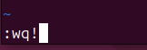 and press Enter key.
- How to go Home directory?
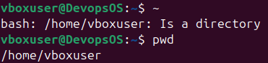
- How to check all directory?
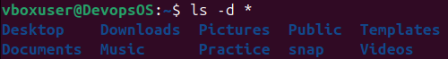
- How to hide directory?
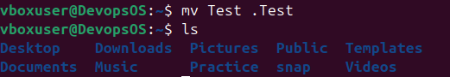 it not show us Test directory.
- How to unhide directory?
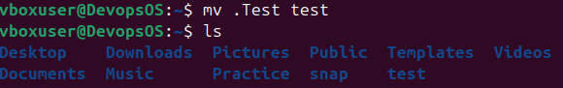 it shows us Test directory.
- How to delete directory?
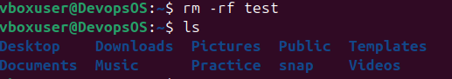 test directory is deleted.
- How to rename directory?
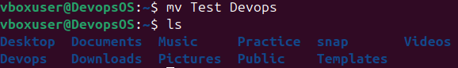
- How to move directory in Practice directory?
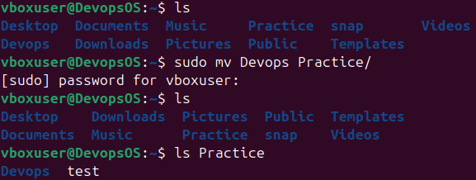
- How to move Devops Folder inside of practice folder?
